**Restful API Instructions**

I am useed ASP Boilerplate (abp) framework to Implement this RESTful API

It is a straight forward implementation as I tried to use a DDD pattern which abp supports.

In the attached zipped folder **(Postman Endpoints with API_Database Backup.zip)**, you will find the SQL Server Database for the “account” and the “acccountbalances” table with the postman JSON file containing all the endpoints which I set up for this test.

The db also contains some other tables which were generated through entity framework code first approach and some abp tables that helps to handles a secure authentication for this Restful API.

The database which abp provides has about 9 users/role-based authentications. They store user login attempts and app settings table, notification, etc.

**Reason for using abp:**

ABP provides Multi Tenancy Application.

It allows for various options if one does not need to configure Multi Tenancy.

And it provides common web portal functionalities as well. Functionalities like login and logout user management, localization, and host of others.

**Endpoints or exposed Methods from Postman IDE**

I have implemented 5 methods, starting with login which you will need to run first before you could gain an authorisation to call other APIs and get a response from the server. Below is their screenshot of them:

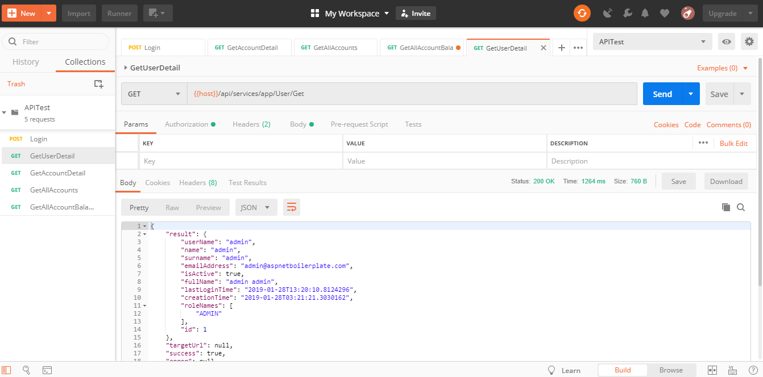

The **GetAllAccountBalance** method, can be used to test for string, more than 20 characters and some special characters and observe the response returned from the server. A screenshot is also provided below:

**How its implementation works:**

When the action is requested it is automatically binded with matching variable names from the controller class and then it look for the validation attributes.

And if not valid, an error messages will be returned as a response to be served to the client.

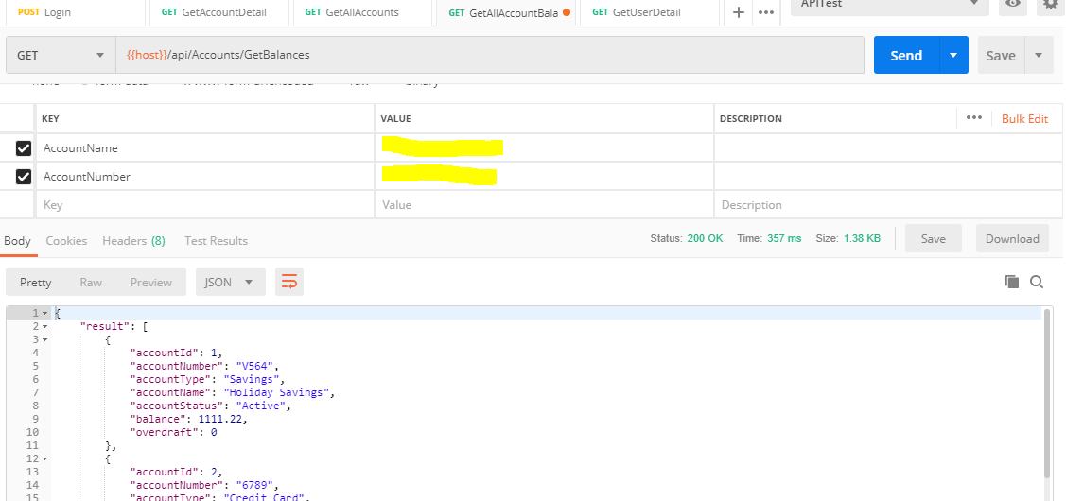

The files and classes I implemented into the abp framework are these ones shown on the screenshot below.

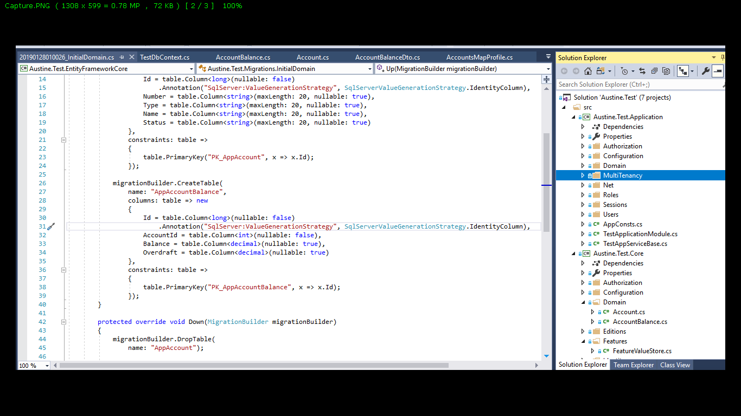

**Managing Multiple User’s Credentials:**

Suppose one wants to give another user a different credentials to access the API, he will add it from db using abp user and role management options.

Thanks for reviewing.

Regards,

Emeka.